Case Discussion – Case Submission Form

Homeopath: <Your name>
Case Discussion Date: <Date>

Basic Client Information

Age
Gender
Chief Complaint(s)
Last Homeopathic Prescription
Date of Last Follow-up

Family Health History

Relation | Diagnosis / Health Condition | Miasm/Nosode
Siblings
Mom
Dad
Grandparents

Current Client Pharmaceuticals & Supplements

Rx/Product | Reason | Yr/Date Started | Notes

Client Health History

Age/Year | Diagnosis / Health Condition | Miasm/Nosode

Miasmatic Indications in Client and Family

- Syllitic

- Cancer

- Tubercular

- Sycotic

- Psoric

Chief Complaints & Observations

- Chief Complaint
- Onset:
- Etiology:
- Endogenous OR Exogenous:
- Nature:
- Modalities:
  - Better:
  - Worse:
- Concomitants:
- Frequency:
- Intensity:
- Classification of Disease:
- Chronic Miasm/Nosode:
- Intercurrent:
- Current state:

- Chief Complaint
- Onset:
- Etiology:
- Endogenous OR Exogenous:
- Nature:
- Modalities:
  - Better:
  - Worse:
- Concomitants:
- Frequency:
- Intensity:
- Classification of Disease:
- Chronic Miasm/Nosode:
- Intercurrent:
- Current state:

- My Observations

Case Status Summary and Questions

- Case Status

- Discussion Questions

Form Instructions

- Client Health History: Provide client health history. Considerations:
  - Injuries
  - Surgeries
  - Infections (esp. recurring, severe or lingering)
  - Toxic exposures or bad responses to chemicals or pharmaceuticals
  - History of pharmaceuticals (steroids, antibiotics, synthetic hormones), esp. those that were suppressive or triggered heath issues
  - Covid vaccinations and any other vaccinations that triggered health issues
  - Allergies
  - Any significant life events or stressors
  - Anything that resulted in a “never well since” situation

- Family History: For genetic relatives only! Provide the health history for siblings, parents and grandparents focusing on their health issues. This will likely look like a list of diagnoses with the corresponding miasm or nosode. If deceased, provide cause of death and age. Look for the client’s issues to appear in the family!

- Miasmatic Indications: Using what you’ve identified in the client and family members, make a list of issues pointing to each miasm. Focus on syphilitic, cancer, tubercular and sycotic. Psoric is underlying most chronic disease and you will not start homeopathics using Psorinum. The ultimate goal is to identify the chronic miasm behind each of the client’s chief complaints.

- Chief Complaints: Give a name to each symptom or symptoms that present/go together. Complete this list for the client’s chief complaints. These represent the most important health issues right now and should NOT be a comprehensive list of symptoms ever experienced throughout the client’s lifetime. You can add more than two if you feel it’s necessary. You may not know some of the answers but try to identify as many as you can. However, it’s critical to understand and identify the classification of disease for all chief complaints. If you don’t know, at a minimum add your thoughts. Use the flower picture below as a guide.
  - Onset: When did this start?
  - Nature: Define all aspects of the symptom(s) including but not limited to location, type of pain, type of sensations, timing, periodicity, etc. Note modalities and concomitants are listed separately.
  - Classification of Disease: Identify where you are in Ewald’s flower with petals. You can identify multiple petals if they apply.

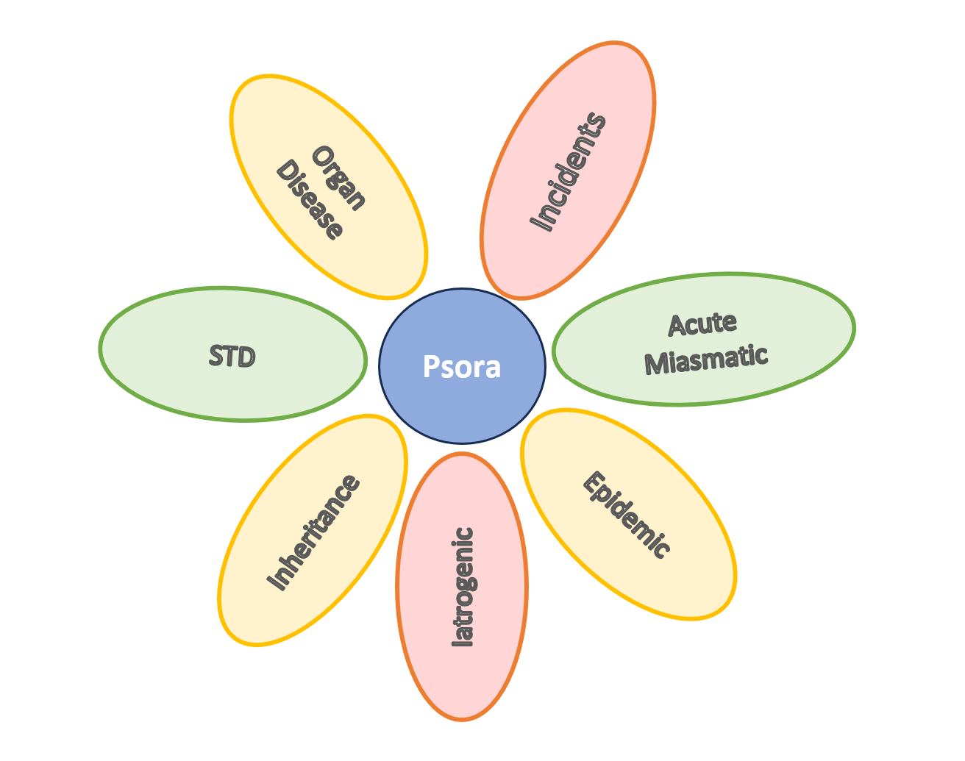
  - Chronic Miasm/Nosode: Note your thoughts on if this is chief complaint is coming from a chronic miasm and, if so, which one (or list the nosode).
  - Intercurrent: Note your thoughts on if an intercurrent is needed and, if so, which one makes sense and why.
  - Current state: Describe the current state of this chief complaint.

- My Observations: Provide your observations that will be helpful for the case discussion.

- Case Status Summary and Questions: Provide a summary of the current state of the client’s case. Identify any questions or help needed at this time.

